





The 2014 Minas Gerais Drought

PS Baker & R Ruiz Cardenas CABI & Federal University of Minas Gerais www.cabi.org
KNOWLEDGE FOR LIFE
Drought in Minas Gerais (MG)

● We present here some facts about the extreme weather in MG over the past two months
● We draw upon a very extensive meteorological database developed with assistance from the Initiative for coffee & climate (www.coffeeandclimate.org)
● Data was analysed at the Federal University of
Minas Gerais
Jan 1981-2010 average rainfall

a crucial time to support berry development

Area coffee planted

Accumulated rainfall (mm) for January in Minas Gerais (1981-2010 climate)
Jan 2014 rainfall

Accumulated rainfall (mm) for January in Minas Gerais (2014 only)

Feb 1981-2010 average rainfall



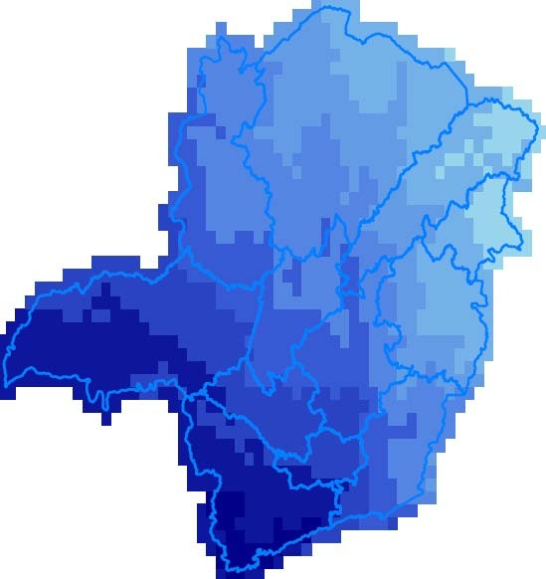

Accumulated rainfall (mm) for February in Minas Gerais (1981-2010 climate)
Feb 2014 rainfall

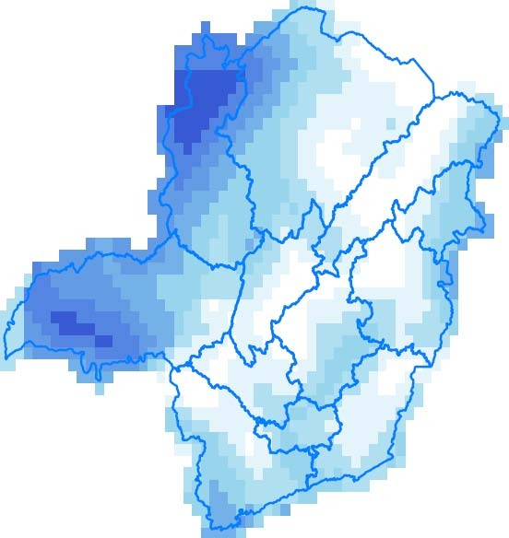

Accumulated rainfall (mm) for February in Minas Gerais (2014 only)
Jan 2014 rainfall was very similar to

Jan 1956

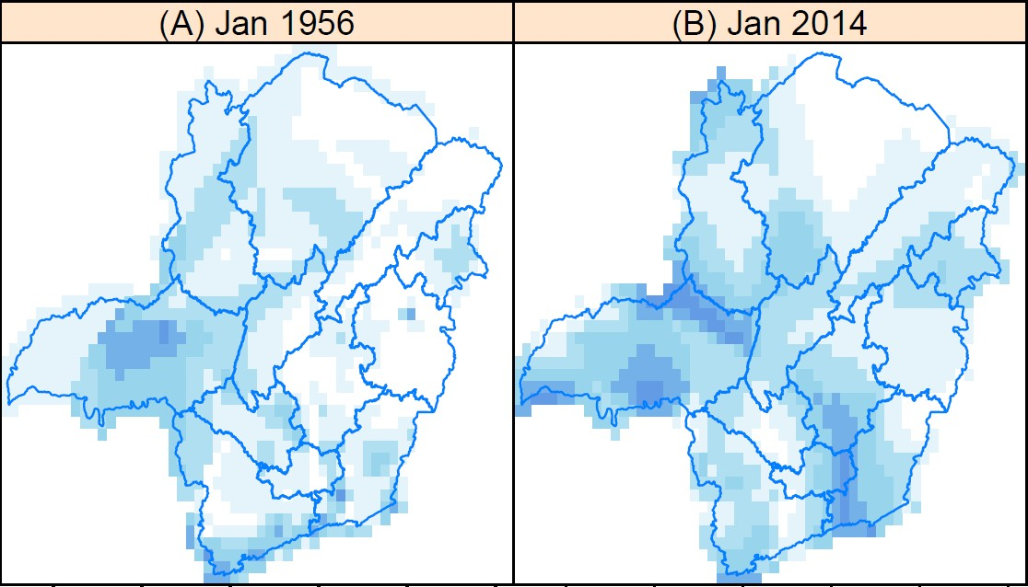
Feb 2014 rainfall was similar to

Feb 1977

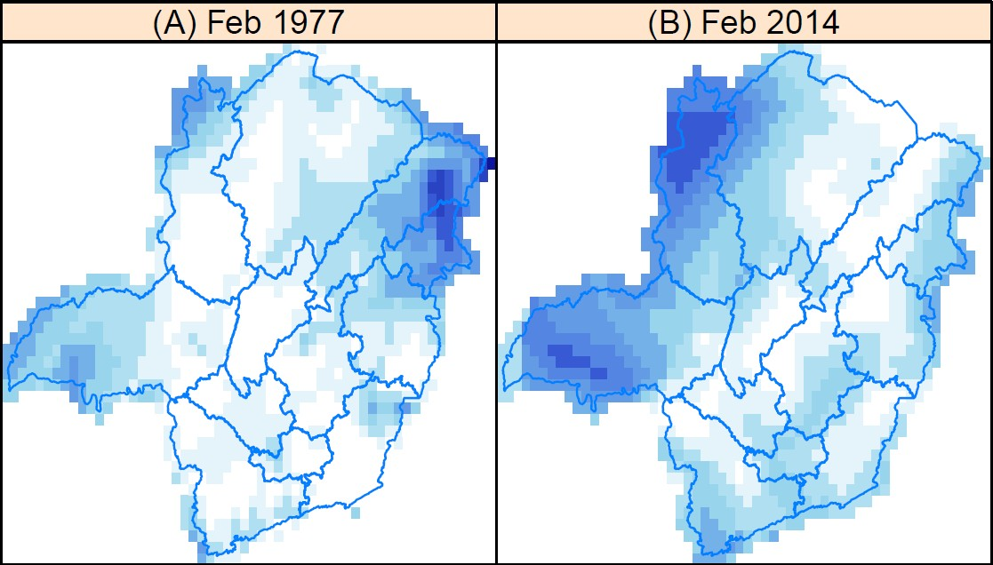
Combined Jan+Feb rain deficit approaches

500 mm in Sul de Minas
Much of the state’s coffee is in the hardest hit zones

Hectares

Municipalities of Minas Gerais with more than 10 Ha of coffee planted in 2012
according to IBGE.
Drought is combined with high temps

Mean Jan-Feb Tmax up to 4oC more than normal

Jan 2014 Feb 2014

Mean daily maximum temperature anomaly (oC) for Jan & Feb 2014 in MG (difference between the mean daily maximum temperature in 2014 and the 1981-
2010 climate normal).
oC
anomaly
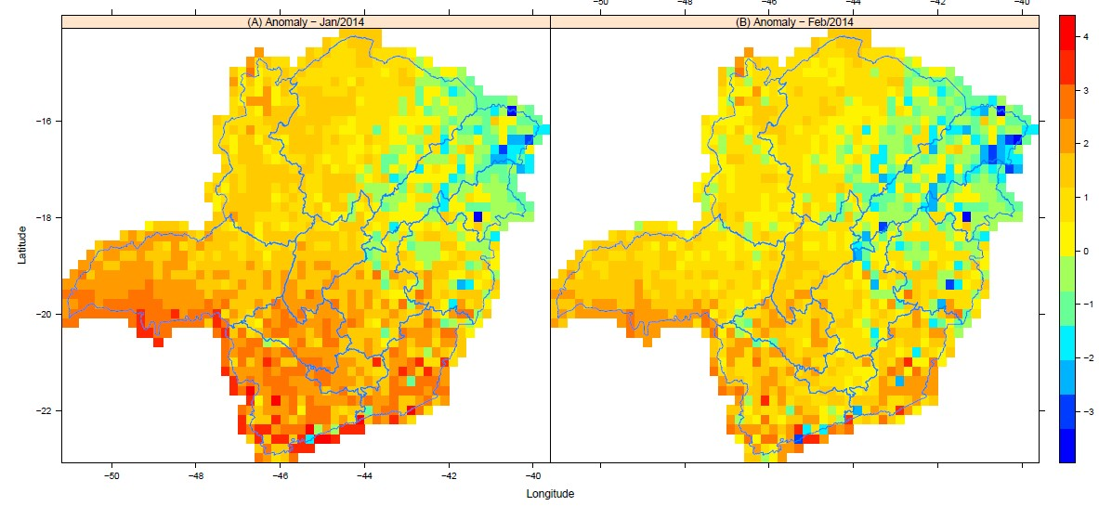

Mean daily Tmax over 30oC in many zones

1981-2010 2014
An unprecedented drought?

● We can find no similar two month period of such extreme Jan-Feb drought in the meteorological records
● Records become increasingly scant and unreliable pre-1960
● But it seems quite certain that any similar event as
the current MG drought would have to be pre-1950
● So it’s a very rare event
Berries not filling…

[Courtesy of Cristiano Soares]
85% floaters!

[Nivaldo M. Tavares Commercial Director of Cocatrel]

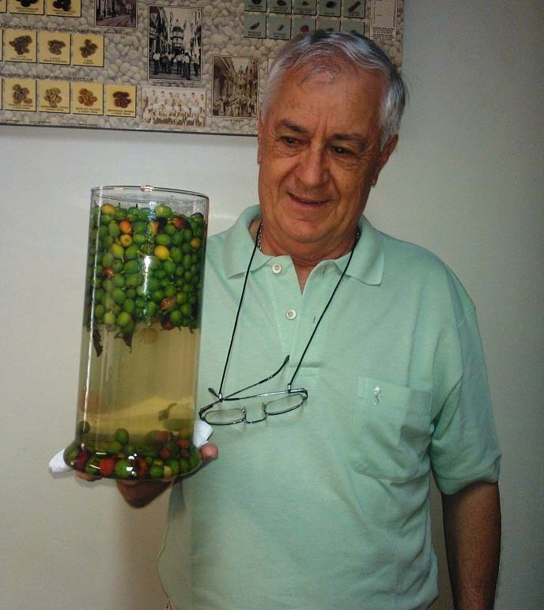
Is it climate change?

● Droughts happen – we cannot blame a single drought on climate change

● But is it likely that climate change has made it
worse?
● Yes – MG temperatures have been rising for
decades
● In fact the whole region has been warming quite
substantially:
Trend of warm days increasing strongly in Central S America

(Warm days = those above 90th percentile of daily historical Tmax)


Patterns of the 1951–2003 trend of the index for warm days (in C/decade) estimated from the observations and the ensemble mean of model experiments with ALL forcings (Christidis et al. 2013)
Tree cover loss (1860-2010)

Just a coincidence?

Patterns of the 1860–2010 trend in tree-cover fraction per decade
Estimated warming trend due to land use change only

Patterns of the 1951–2003 trend of the index for warm days (in C/decade)
estimated due to land use change only (Christidis et al. 2013)
Another study (Hua Wen Jian et al 2013)

Mean temp change due to land use change

Changes in annual mean surface air temperature due to land use change
(hollow circles show the 0.05 significance level). Hua Wen-Jian et al. 2013
Atlantic forest biome

Severely degraded
Vietnam: similar story?

Central Highlands Decreasing rain in early-mid wet season

Jan Dec

c&c collaboration with: Phan Van Tan, Ngo Duc Thanh, Nguyen Van Hiep
Vietnam National University in Hanoi,
Vietnam Institute of Meteorology Hydrology and Environment
Vietnam: with fast increasing temps
0.7oC+ per decade in some months

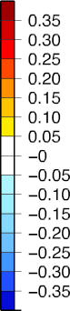

Degrees/decade

Jan Dec
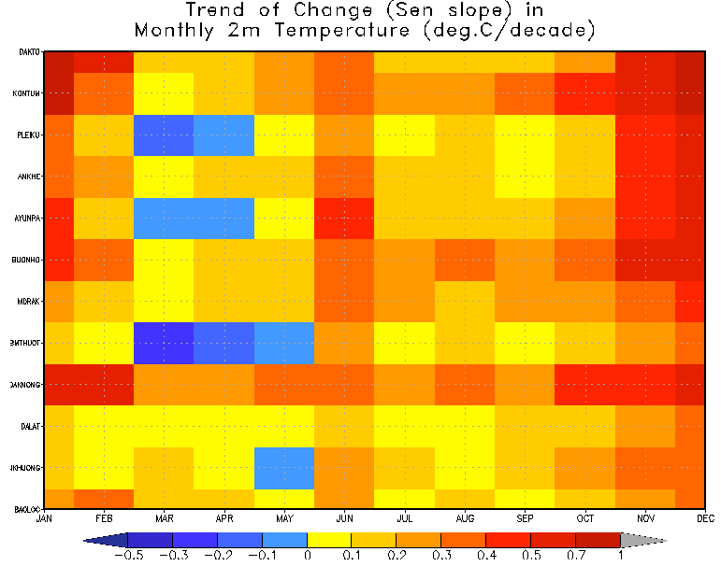

c&c collaboration with: Phan Van Tan, Ngo Duc Thanh, Nguyen Van Hiep
Vietnam National University in Hanoi,
Vietnam Institute of Meteorology Hydrology and Environment

Increasing extremes

● It is likely that major deforestation would make any normal drought worse
● Forests buffer extreme climate – canopy evaporation cools the local climate and increases the chance of cloud and rain formation

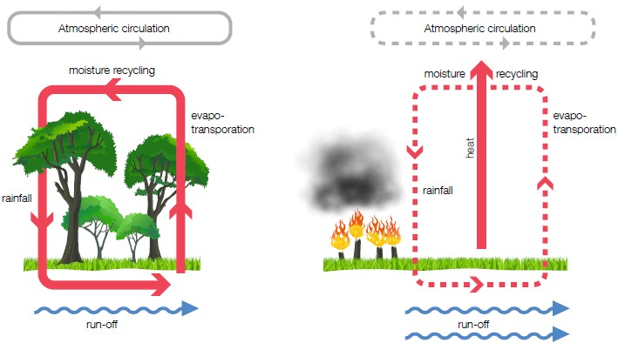
Conclusions

● Drought not caused by climate change
● But very likely made more intense by it
● Two types of climate change need to be considered:
● Global warming – drought has a higher base
temperature
● Regional warming caused by land use change –
lack of evaporative cooling and reduced
precipitation
Such a drought is a rare event

● But rare events are becoming common!
● Colombia (2008 – 10): unprecedented rains
● Central America, Peru 2012-13: major rust
outbreaks
● Brazil 2014: drought
● E Africa, India, Indonesia, Vietnam: droughts and
unseasonal rains increasing over past few years
Playing the climate lottery?

● Do you think the extreme events of the past few years all random occurrences?
● Or is it time to join the dots?
● This problem will not go away
● Expect more severe events in the future
● We must act now and in concerted fashion
Some of c&c’s adaptation work in MG
(Lage et al. – mostly drought-related)
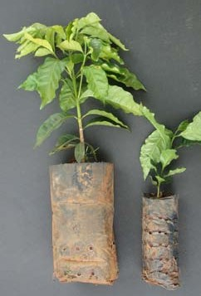

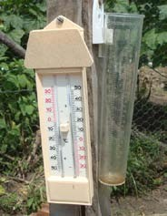

Bigger planting bags
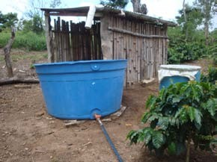

Rainwater harvesting
Met. data collection

c&c toolbox

Gypsum applications

Ground cover & mulch

Shade trials

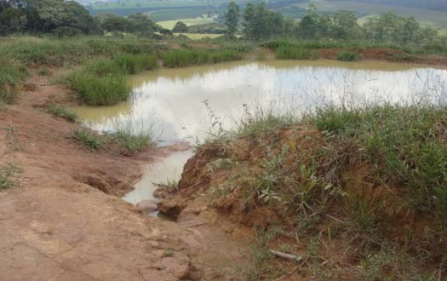

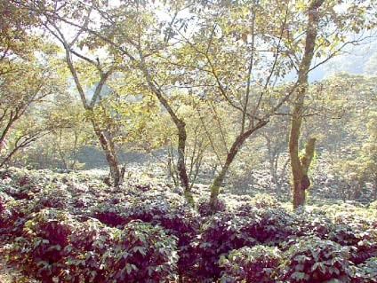

Hydrogel
applications Wind breaks Run-off & infiltration

There are a lot of adaptations that can be tried

● c&c has developed a robust and science-based approach to CC adaptation
● Each coffee country should developing its own adaptation tool-kit to confront to locally derived priorities
● A lot is already available that can be applied over
the short to medium term
Christiana Figueres, UN Climate Head [London interview March 2014] Discussing extreme weather events:

"If you take them individually you can say maybe it's a fluke. The problem is it's not a fluke and you can't take them individually. What it's doing is giving us a pattern of abnormality that's becoming the norm.

These very strange extreme weather events are going to continue in their frequency and their severity … It's not that climate change is going to be here in the future, we are experiencing climate change."

Thank You
www.coffeeandclimate.org p.baker@cabi.org www.cabi.org

www.cabi.org
KNOWLEDGE FOR LIFE

